Call for Erasmus+ Staff Mobility for Training

Key Action 1 of the Erasmus+ Program provides funds for short-term trainings or arrange an individual visit on administrative staff’s own initiative at a partner institution in eligible program countries. This program is called ‘Staff Mobility for Training’ and at Abdullah Gül University program coordinated by the Erasmus Office. STT mobility may include: participation in specialized courses, staff training weeks at other universities, workshops, exchange of know-how within job-shadowing visits or a combination of these.

Funding

The administrative staff members participating in the program may receive funding, including contributions for travel costs and subsistence during the period abroad. The subsistence grant is a contribution towards all other costs for the individual including travel within the city, accommodation, meals and snacks.

Funding for travel expenses: For each participant, the distance for travel is calculated by below ‘Distance Calculator’ provided by European Commission:
http://ec.europa.eu/programmes/erasmus-plus/tools/distance_en.htm
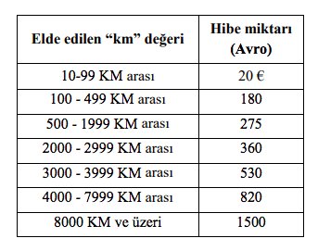

Funding per day: The amount of support provided per day per country is determined by the National Agency (www.ua.gov.tr).

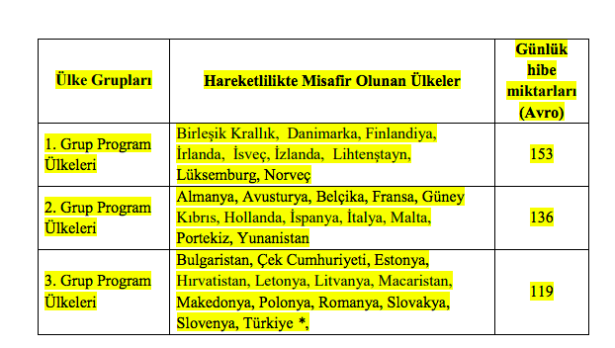

EU Grant support for the Mobility of staff Table 1: Daily Amounts for Erasmus+ Teaching/ Training Staff Mobility
Duration of mobility
The eligibility period of the Erasmus+ Mobility for Teaching should be between the 01/06/2018 – 31/05/2020.

Please note that all mobility activities must end before May 20, 2020.

The minimum duration for Erasmus+ Mobility for training is 2 days and the maximum duration is 2 months.

To increase the number of participants, Abdullah Gül University funds;

- Mobilities for at most five days two of which may be used for travel. Depending on the available funds extra days may also be reimbursed

In order to be eligible for the subsistence grants, beneficiaries will need to make travel arrangements for their mobility period up to one day before and one day after the actual training mobility dates.

How to apply

Teaching and Administrative Staff should contact the corresponding department of the partner institution, communicate and arrange his/her own Erasmus exchange visit. The host institution may assist you in finding on or off- campus housing and send you an invitation letter for the visa, if needed.

To be able to participate in this mobility program, there is no need for an Erasmus+ agreement between AGU and host institution.

All full time administrative members who wish to take part in this mobility program should send approved (signed and sealed) training program (completed) with invitation letter.

All teaching and administrative staff who wish to take part in TSM should send, via e-mail, application form, Training Staff Mobility Form, invitation letter, work plans, the names of the partner institution and the academic unit they wish to visit, and the expected dates of their mobility, to erasmus@agu.edu.tr no later than Monday, December 17, 2018, 17:00.

Selection Criteria

Official letters of invitation from the partner universities and approved work plans should be submitted to our Office before the date above.

- At least one year of work experience at AGU: + 5 points
- For each extra year of work experience at AGU: + 5 points
- Currently, Erasmus Department Coordinator/Assistant: +10 points
- Previous Erasmus Department Coordinator/Assistant: + 5 points
- Quality and the relevance of the training program: + 25 points
- Being abroad before for any training purposes and for each instance: - 10 points
- Evaluation of the “How the mobility experience will contribute to AGU” Statement: + 0 to 15 points
- Evaluation of the “How the mobility experience will contribute to staff’s personal development” Statement: + 0 to 15 points
- Language Level 1 : + 40 points for KPDS/YDS .GE. 90, TOEFL IBT .GE. 108
Language Level 2 : + 30 points for KPDS/YDS .GE. 80, TOEFL IBT .GE. 96
Language Level 3 : + 20 points for KPDS/YDS .GE. 70, TOEFL IBT .GE. 84
Language Level 4 : + 10 points for KPDS/YDS .GE. 60, TOEFL IBT .GE. 72
Here .GE. stands for “Greater than or Equal to”. One can get a Language Point from only one of the Language Levels.

P.S Earlier applications will be given priority among applicants having the same criteria points.

Any faculty/administrative staff member wishing to do so may take part in STM without requesting financial support.

Applicants, who will not be awarded a grant on the basis of lack of funding, will remain on a reserve list and will be awarded grants if funds become available in due course.

Please visit www.erasmus.agu.edu.tr for information regarding partners, Erasmus + coordinators, sample of documents and other related issues.

If you need any further information please to not hesitate to contact us via e mail erasmus@agu.edu.tr

